Practical - 1
Practical Title: Project Initiation, Requirement Analysis, Sitemap, Wireframe, and GitHub Setup
Problem Defination: Initiate the semester-long StudentHub portal by identifying the problem scope, user roles, key modules, navigation flow, and minimum 10 pages. Create a sitemap, low-fidelity wireframe, project folder structure, README file, and GitHub repository.
- Theory:
1.What is URL and parts of URL?
Answer: A URL (Uniform Resource Locator) is the web address of a page. Its main parts are protocol (https://), domain name, path, and file name/query.
2. How does HTML file processed in web browser?
Answer: The browser reads the HTML file, builds the page structure, applies CSS for styling, and executes JavaScript for interactivity before displaying the webpage..
3. How will page navigation flow managed among all HTML pages?
Answer: Navigation is managed using hyperlinks (<a> tags) and a common navigation bar on every page for easy access.
4. How will GitHub commits be maintained after each practical?
Answer: A separate commit is made after completing each practical with a clear commit message to track changes and project progress.
- Implementation/ Output/Result:
Requirement Analysis
The StudentHub portal is designed to provide a centralized platform for students to access academic and campus-related information. The system includes modules like login, registration, dashboard, profile, attendance, events, feedback, and admin management.The requirements include creating a user-friendly, responsive, and accessible website with a minimum of 10 pages.
- Evidence of Work (Screenshots):

Home page:
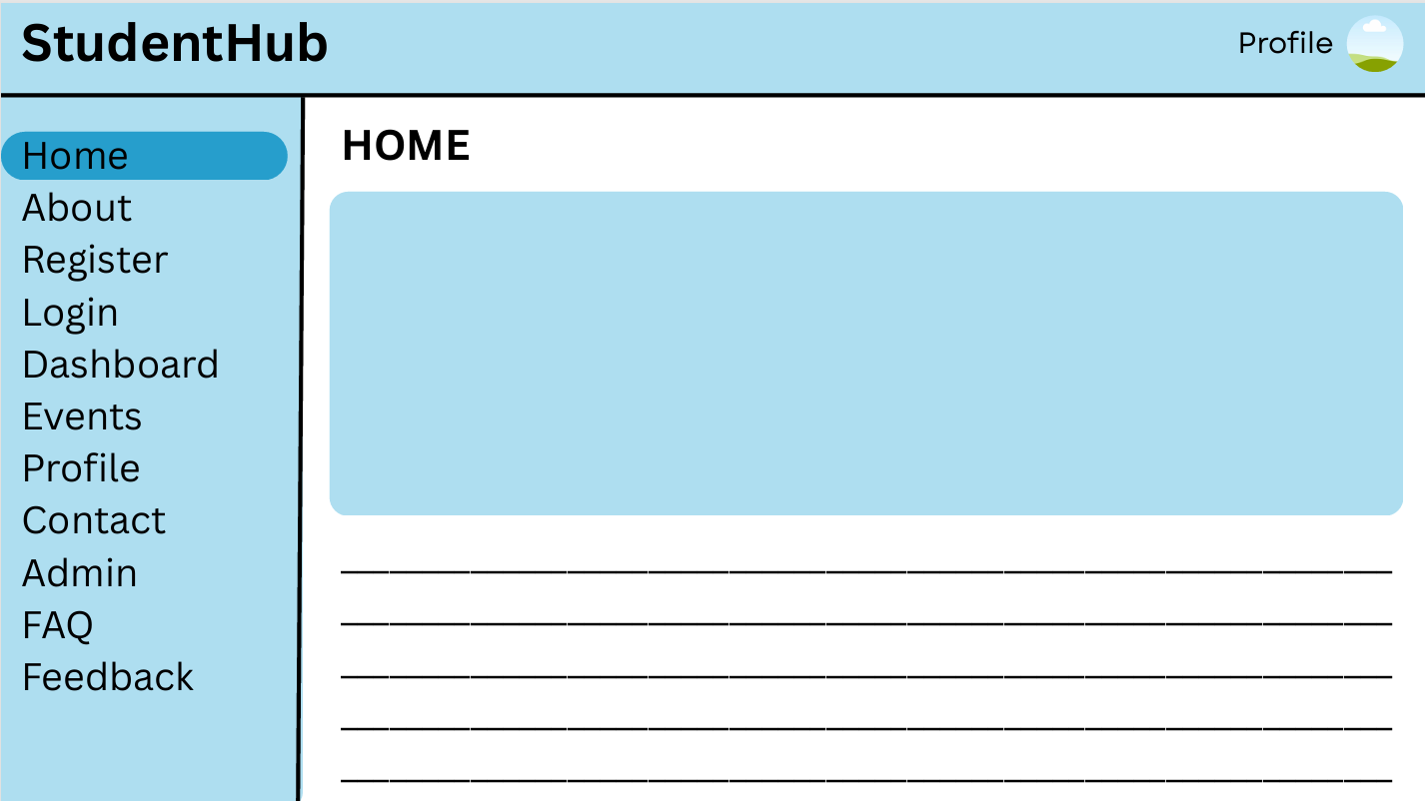
About page:
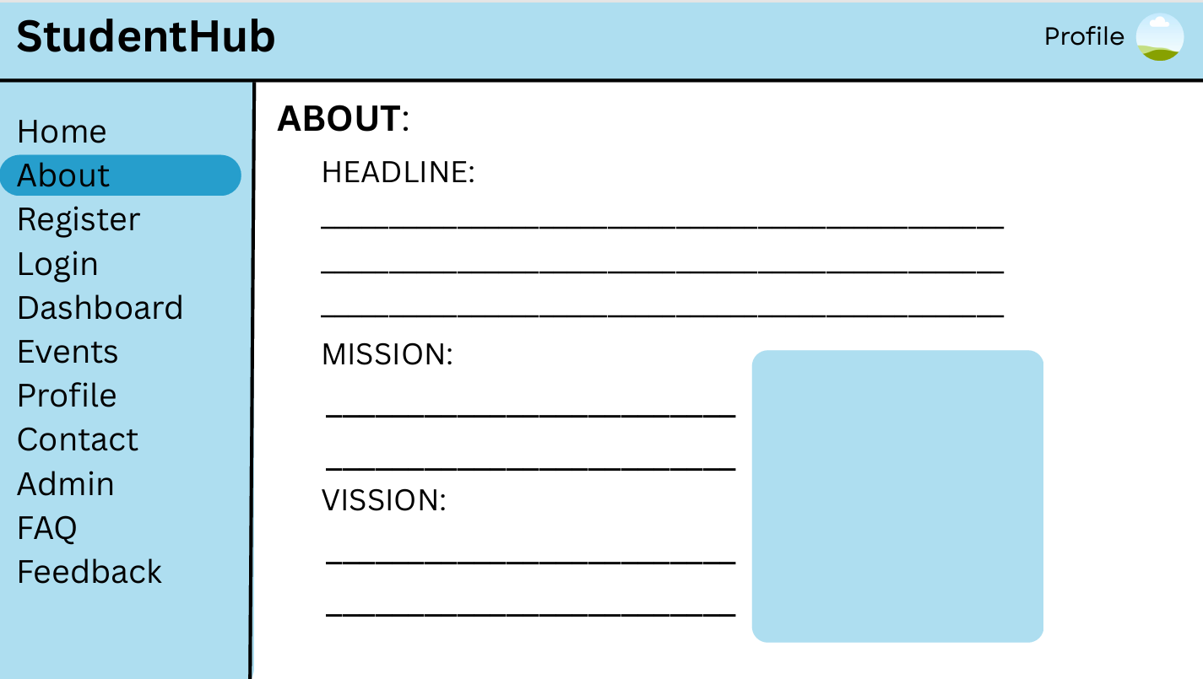

Admin page:
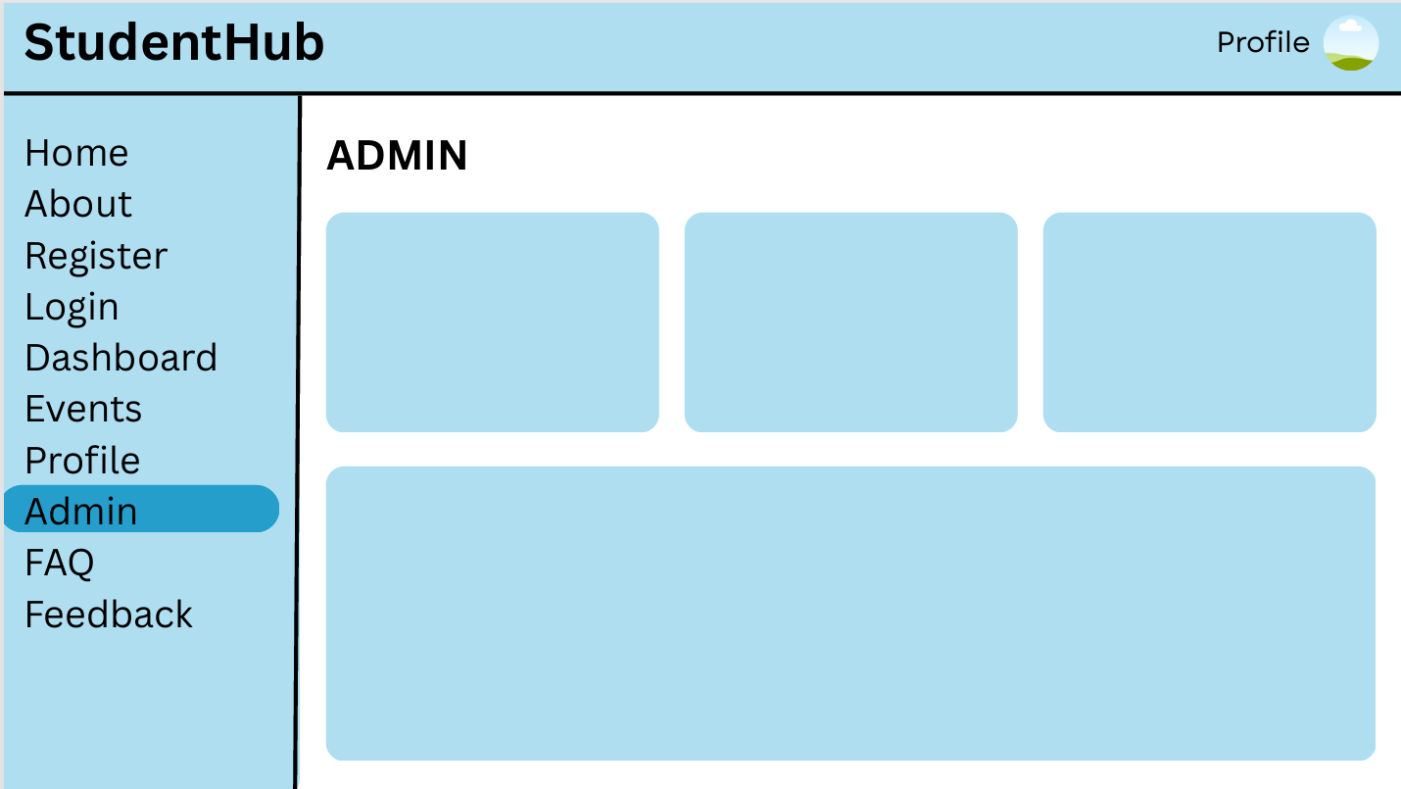
Dashboard page:
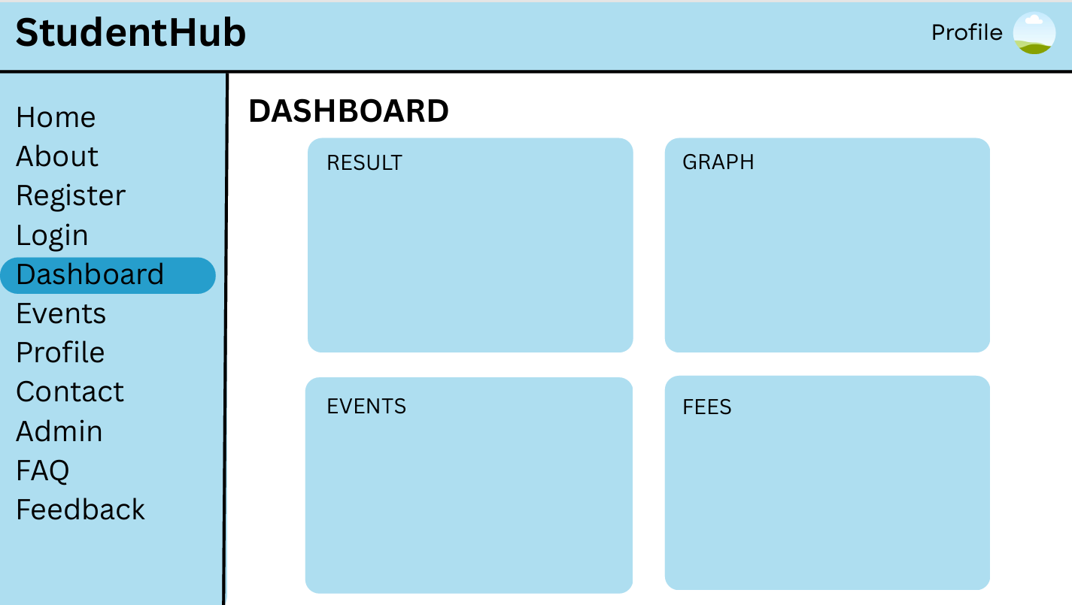

Event page:
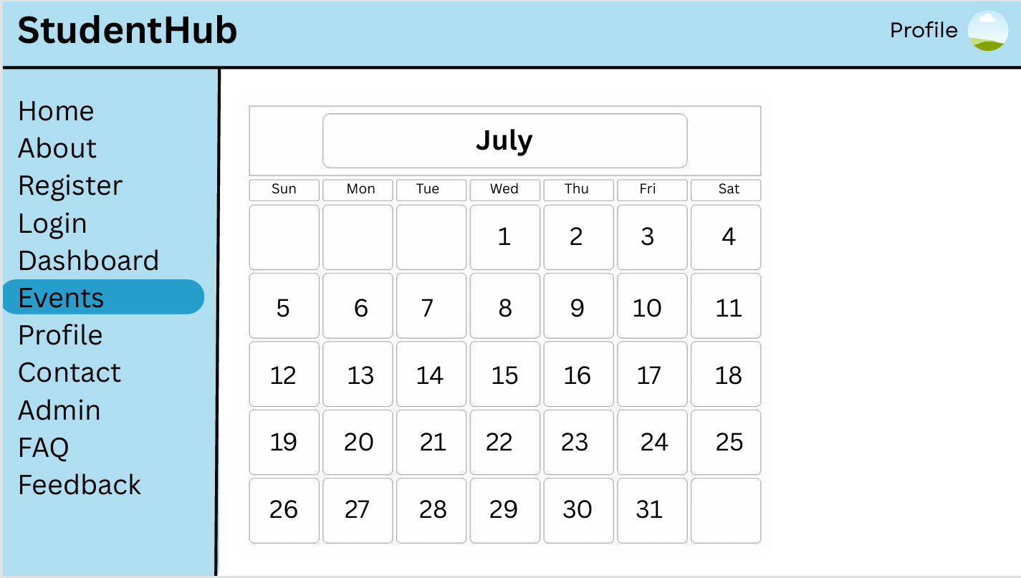
FAQ page:
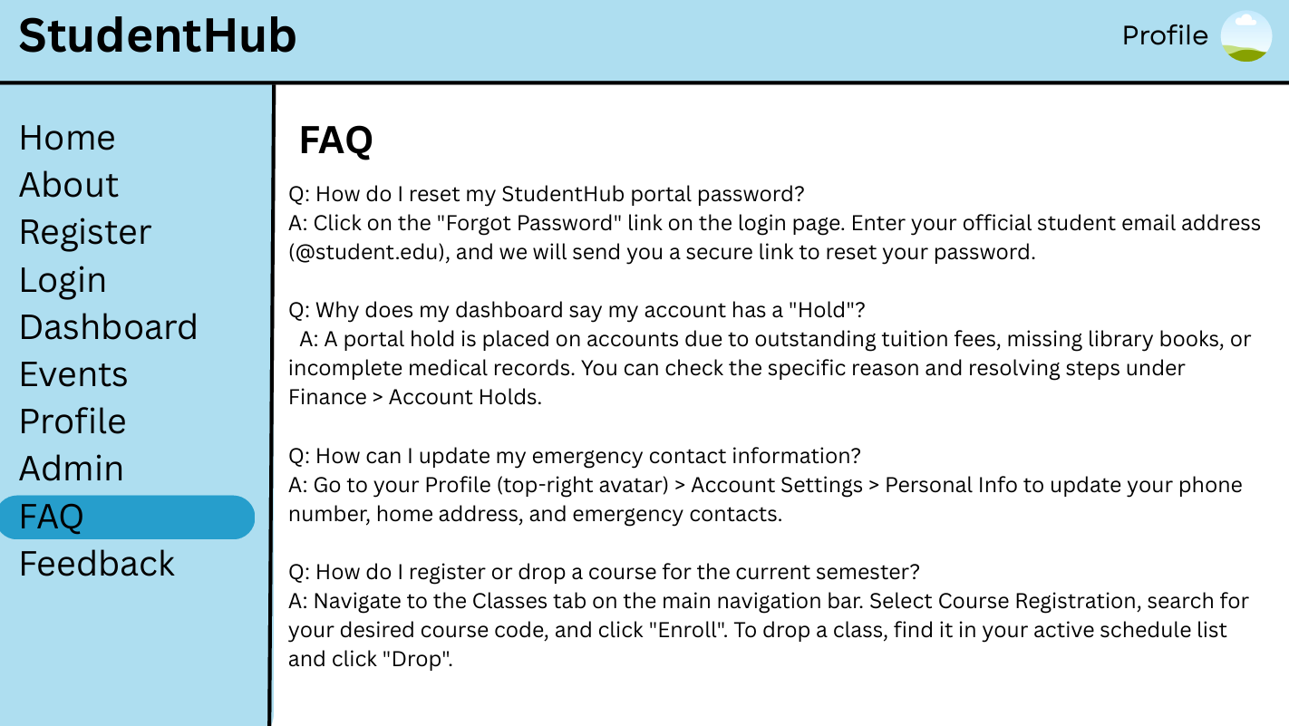

Feedback page:
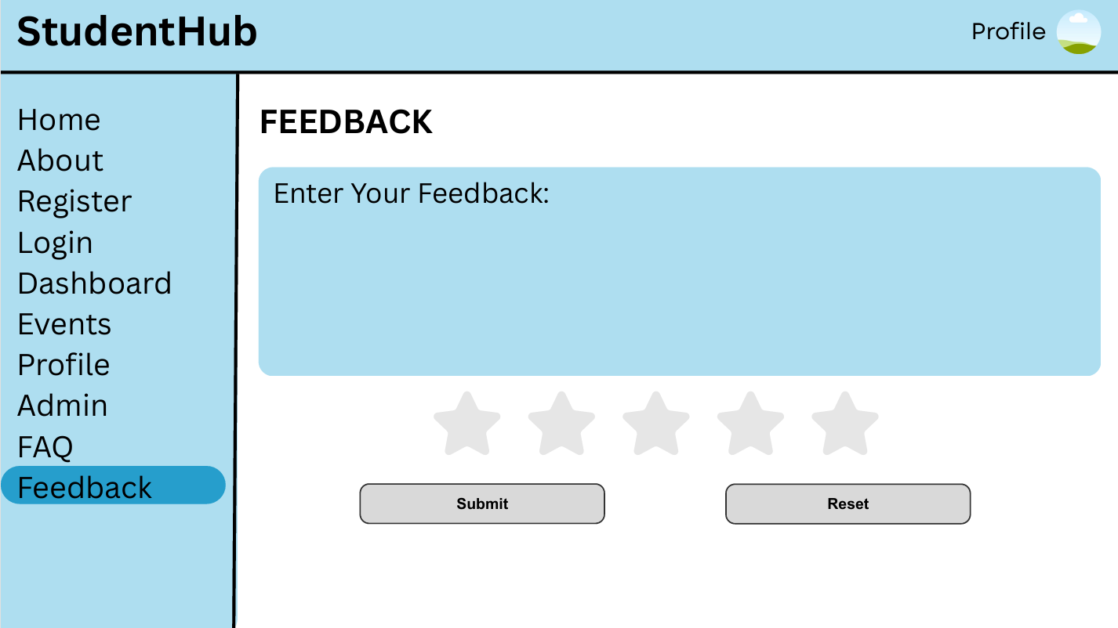
Login page:
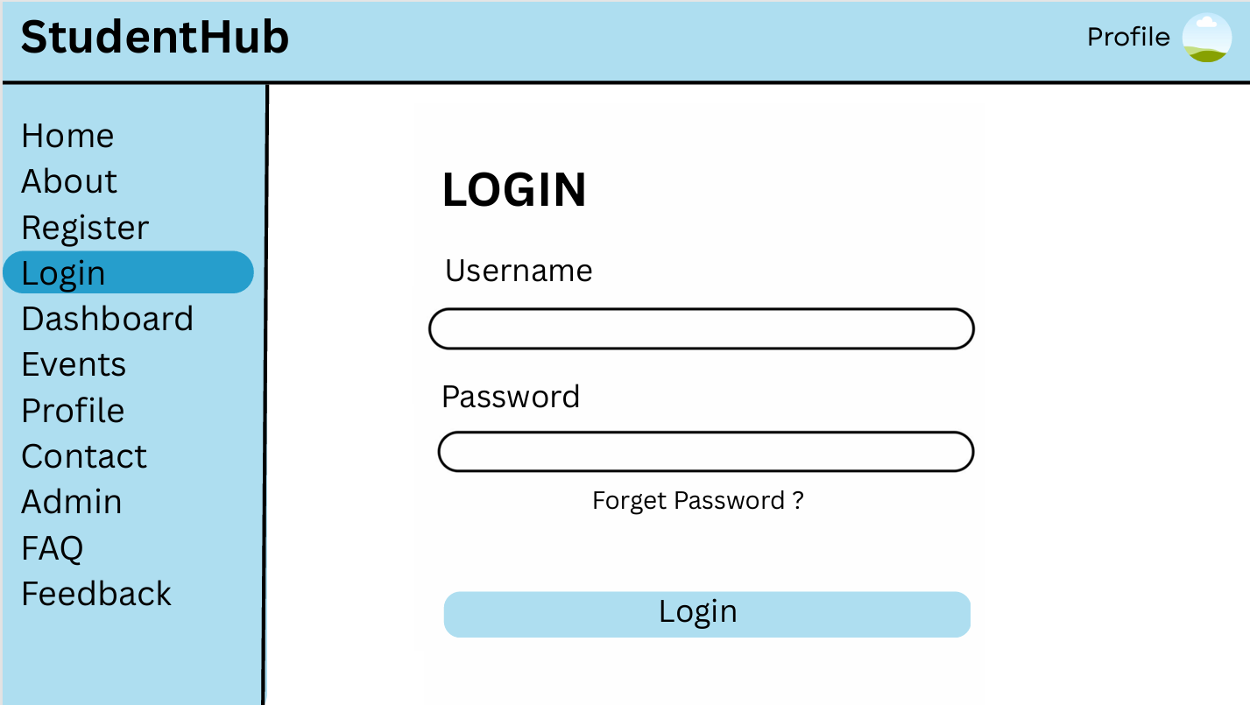

Profile page:
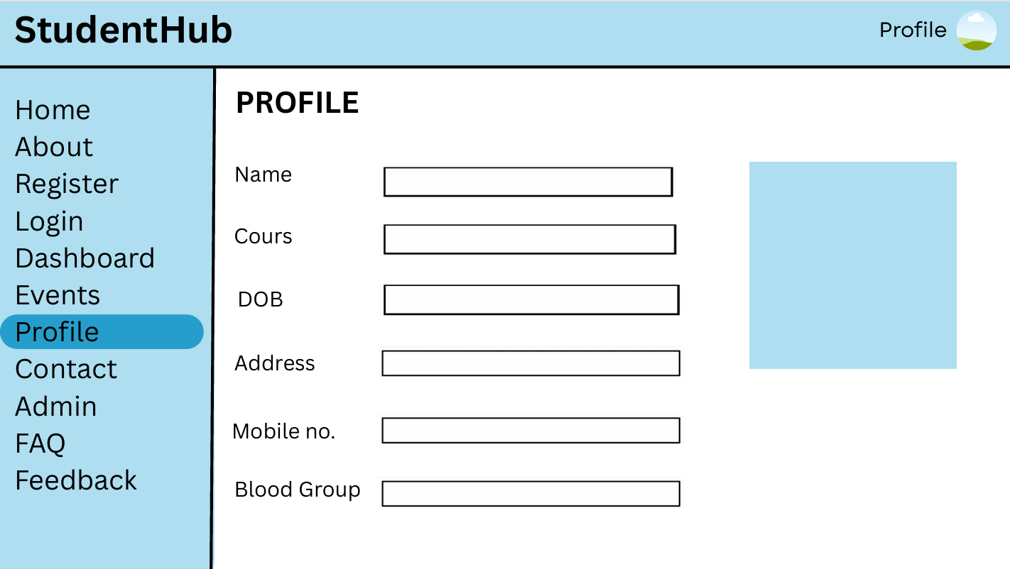
Register page:
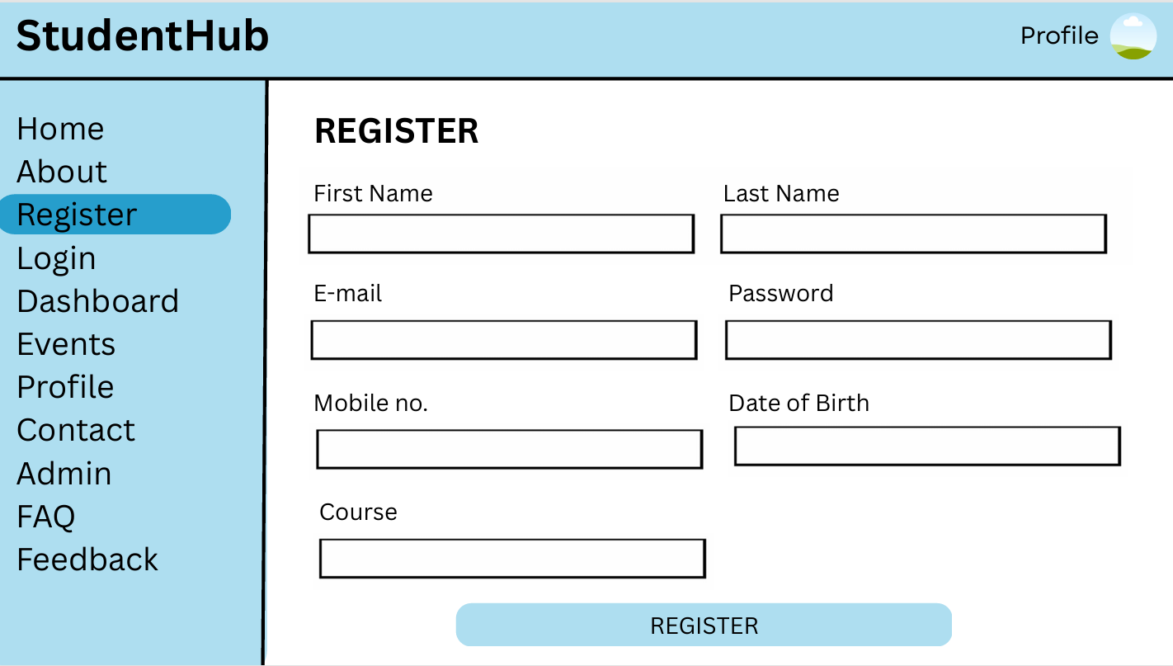

GitHub Repository Link:

StudentHub/wireframe at main · savaliyariya03/StudentHub

- Challenges Faced:
Planned the project structure and navigation.
Created the sitemap, wireframe, and GitHub repository.
- Learning Outcomes:
Learned project planning and website structure.
Understood navigation flow and GitHub version control.
Improved website organization skills.

Faculty Remarks:

